Name: _____________________ Period: ____ Date: ________

Where Is The Carbon?

Ecosystems are communities of living organisms and their non-living environment. Living organisms can be as small as microscopic bacteria in the soil, or as large as the largest tree in the forest. The organisms you find in an ecosystem depend a lot on where the ecosystem is located on Earth. This changes the average temperatures, rainfall, and hours of sunlight the ecosystem receives, among many other factors. That is why we have many, many types of ecosystems on Earth, from deserts to grasslands to tropical forests.

Look at the two ecosystems below. On the right is a desert ecosystem found in the southwest of the United States, in Arizona. On the left is a forest ecosystem found in the Midwest of the United States, in Michigan.
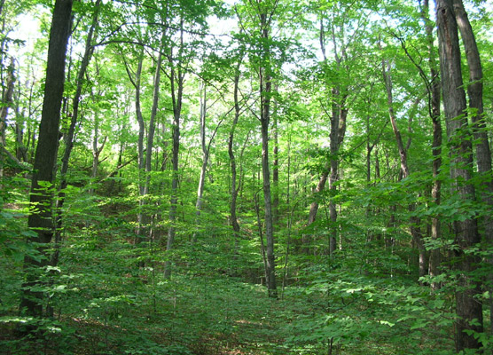
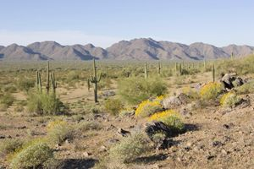

1. Which ecosystem do you think stores the most carbon? Explain why this ecosystem has more carbon than the other ecosystem.

2. Name all the places where you would find carbon in the ecosystems?

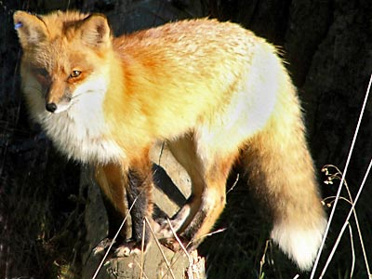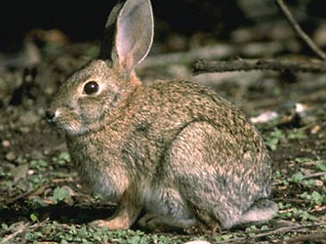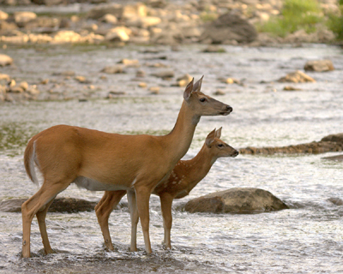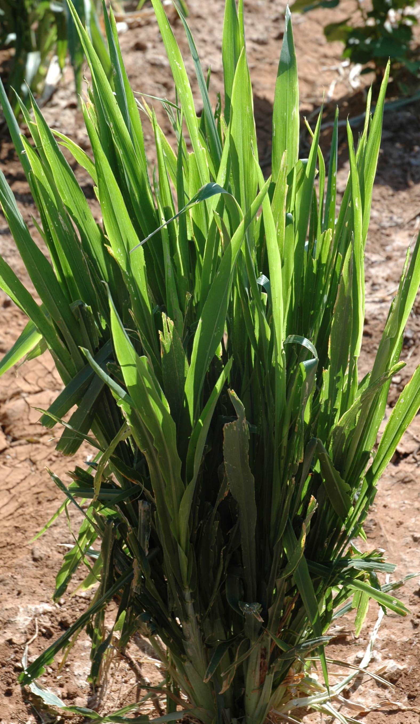In desert ecosystems and forest ecosystems you can find different species of fox, deer, rabbits and plants.

Which one of these populations of organisms would hold the most carbon in the ecosystem?
- All the plant population in the ecosystem
- All the rabbit population in the ecosystem
- All the deer population in the ecosystem
- All the fox population in the ecosystem

3. Explain your choice. Why does that population hold more carbon than the others?

Alex, Blake and Carmen were asked the same question. Look at how they answered the question and circle which answer you think is best.

Carmen: The plants have the largest population so they would hold more carbon than the others.
Alex: Deer are the largest size so they would have the most carbon in the ecosystem.
Blake: Fox are the top predator so they would have more carbon than the others.

4. Why is the one you circled better than the other two explanations?

